  European Union | Building a brighter future
The European Agency for Reconstruction in
Kosovo
News bulletin, March 2002

Upgrading facilities at Pristina University
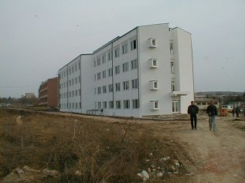
The European Agency for Reconstruction has finished a major programme of works to refurbish and upgrade the heating system at the Students’ Centre of Pristina University. The student dormitories will now receive central heating not only through the district heating system but also through two new oil-fired boilers. “This new system is a huge improvement on the old one”, said Otto-Roman Barnert, programme manager at the European Agency for Reconstruction. “It will be able to provide constant heat to the dormitories, even if the district heating system were to fail. It will also provide hot water to most of the bathrooms.” The work to upgrade the system cost almost €300,000, and was undertaken by Sabrico, a company based in just one part of the European Agency for Reconstruction’s 2001 programme for Pristina University. In total, €1 million from the 2001 programme is being spent to upgrade facilities. Work to improve the electrical systems in the student dormitories; to upgrade the smoke detection system; and to install fire hydrants and fire escapes should be finished by this summer. In addition to the Students’ Centre, the Agency has also finished works to rehabilitate Hospital Block B at the University of Pristina. The works, totalling €500,000, involved the reconstruction of the exterior of the entire building, as well as internal works on the first floor of the building. This newly renovated first floor will provide a home to the future Department of Family Medicine.

Training begins for top-level managers in the health service
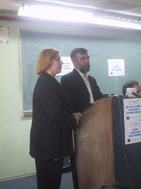
The European Agency for Reconstruction, along with the University of Pristina and the Centre for Health Management, is now training top-level managers in the health service for a master’s degree in health management. The degree in health management will provide senior health service managers with all the management skills required in a modern health system. Fifty people will study for the degree, and the training will take place at weekends over a two-year period. The European Agency for Reconstruction is providing €400,000 of EU funds, and the degree is being organised by the Faculties of Medicine and Economics at the University of Pristina. “In any part of the world, a health service has to ensure health care for all its people, but with only limited resources available to it,” said Odran Hayes, Acting Head of Operations at the European Agency for Reconstruction. “This course will provide health service managers in Kosovo with the training required to manage resources effectively and efficiently.” The course was officially launched on March 7th in the presence of Kosovo’s new health minister, Dr Numan Balic; and Kosovo’s new education minister, Rexhep Osmani. Numan Balic said the training was very important for Kosovo’s health service, and thanked all those who were providing support. As well as providing training for top-level managers, the European Agency for Reconstruction is also providing training for mid-level managers in the health service, as well as training Kosovo’s doctors in the field of family medicine.

Transport update
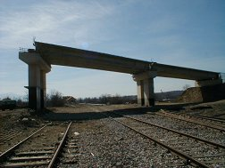
As part of the European Agency for Reconstruction’s transport programme, technical studies have begun for work on the new connection road to be built to Pristina’s airport. Actual construction work on the new road should begin in July 2002. €1.5 million of EU funds are being provided for the project. When the road is completed, there will easier and faster access between the Pristina-Pejë/Pec road and the airport. Elsewhere in the transport sector, work is continuing to reconstruct two war-damaged bridges at Rakovina. They should be completed in April.
Agency facts and figures over the last month Energy:
As result of the overhaul of Kosovo’s coal mines, production levels on February 14th were over 42, 000 tonnes, the highest level for 15 years. Water and Environment: Work has now finished on 16 of the 19 municipal waste disposal sites that the Agency is upgrading to bring levels of waste management up to western European standards. Enterprise Development: The Interim Credit Unit (ICU) set up by the Agency and the World Bank has now disbursed about 50 loans to the value of over €6 million. Another €6 million of EU funds have now been made available for the ICU to extend further loans to Kosovo’s small and medium-sized enterprises. Housing: As a result of the 2001 programme, over 3,400 houses are now complete and 84% of the beneficiaries have moved in.

In April’s news bulletin…..

Details of the European Agency for Reconstruction’s programme for Kosovo in 2002.

The European Agency for Reconstruction in Kosovo
Budget 1998: €7 million
Budget 1999: €116 million
Budget 2000: €256.5 million
Budget 2001: €315.5 million
Total: €695 million
Key sectors: energy, housing, transport, water and environment, health, enterprise development, agriculture, public administration and civil society
As of 28/02/02 | Budget 1998 | Budget 1999 | Budget 2000 | Budget 2001
Committed | 100% | 100% | 100% | 100%
Contracted | 98% | 97% | 92% | 78%
Paid | 97% | 88% | 82% | 53%

